Nepal College of Information Technology
UT
Year: 2009 Sem: Spring (IV)
Prog: ELX/CE Time: 2 hrs
F.M. 70 P.M. 35
Electronic Circuits

1. a. Find the voltage gin v_{l} / v_{s} for the amplifier as shown when (a) emitter bypass capacitor is used and (b) emitter bypass capacitor is not used. Let β=100. [10]

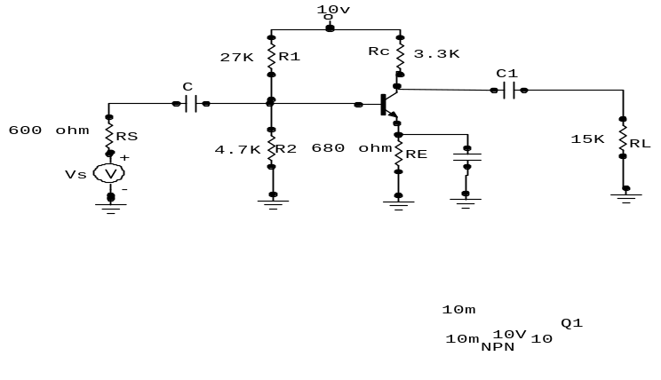
b. Verify the Darlington pair is referred as an “Super Beta ” transistor. [5]

2. a. Define distortion and describe different types of distortion that occurs in amplifier. [6]

b. For the given circuit, two transistors are identical, β=100,r_{c}=1MΩ and r_{e}=25Ω find overall voltage gain(v_{l} /v_{s}). [9]
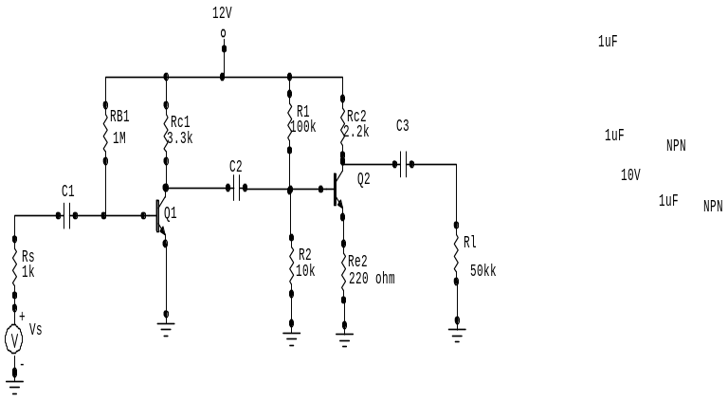

3. a. .Explain about the frequency response of an amplifier. [7]

b. What is negative feedback? How it improves the stability of an amplifier. [8]

4. a. Explain class B operation and show this concept is utilized in push-pull amplifier Find the power conversion efficiency of this operation [8]
b. What is topology? Explain different types of feedback topology. [7]
5. Write shorts notes on(any two) [10]
a) Multistage amplifier
b) Cross over distortion
c) Millers-effect

